SUNDAY WORSHIP 29th AUGUST 2021 at 10:30am in Church at and 10am on Facebook (also broadcast on Outreach Radio)
13th Sunday after Trinity
Service in Church and Facebook
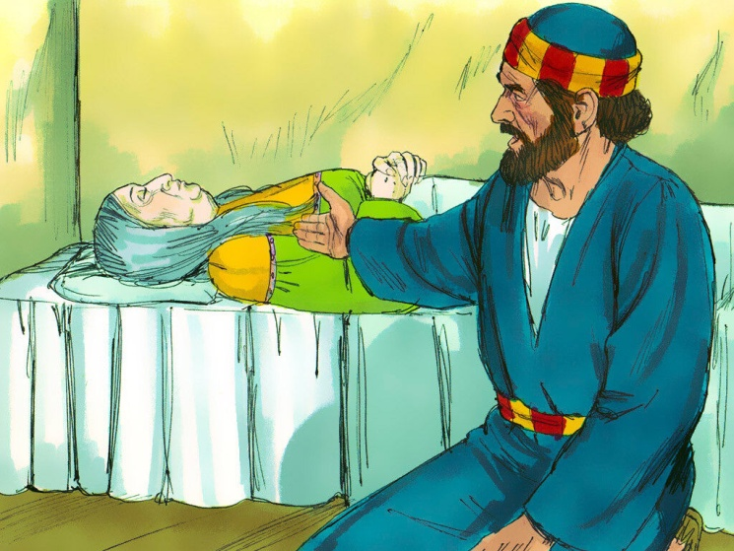

READ THIS SECTION BEFORE WORSHIP BEGINS:
Welcome to our time of worshipping together, but in different places – in Church or at home (either with or without Facebook live streaming, or listening on Outreach Radio).
We suggest that you have a Bible by your side to use.
………………..
WELCOME & INTRODUCTION:
- Let us take this moment to stop whatever else we are doing and thinking about. This is God’s time. Sit comfortably. Picture Jesus with you, sitting alongside you and be still with Him. Know He truly loves and cares for you and He can be trusted.
- Now picture our church family all joining you to worship God in this moment in church or in their own homes. Know that we are worshipping together, even though we can’t see each other.
- Remember that we are one in the Lord.
- If you aren’t following the service on FB, we suggest that, if you are alone, you say the prayers and readings aloud. If you are with others, choose someone to lead and the rest of you join in with the words in bold. On FB, simply join in the words in bold.
………………….
THE GREETING Chris

The light and peace of Jesus Christ be with you all And also with you

THE CALL TO WORSHIP Chris
Christ our passover has been sacrificed for us: ♦
so let us celebrate the feast,
2 not with the old leaven of corruption and wickedness: ♦
but with the unleavened bread of sincerity and truth.
3 Christ once raised from the dead dies no more: ♦
death has no more dominion over him.
4 In dying he died to sin once for all: ♦
in living he lives to God.
5 See yourselves therefore as dead to sin: ♦
and alive to God in Jesus Christ our Lord.
6 Christ has been raised from the dead: ♦
the first fruits of those who sleep.
7 For as by man came death: ♦
by man has come also the resurrection of the dead;
8 for as in Adam all die: ♦
even so in Christ shall all be made alive.
Christ our Passover has been sacrificed for us:
So let us now celebrate the feast!

THE OPENING PRAYER
Lord, speak to us that we may hear your word.
Move among us that we may behold your glory.
Receive our prayers that we may learn to trust you. Amen.

THE CONFESSION OF SINS
Jesus Christ, risen Master and triumphant Lord,
we come to you in sorrow for our sins,
and confess to you our weakness and unbelief.

Silence is kept

We have lived by our own strength,
and not by the power of your resurrection.
In your mercy, forgive us.
Lord, hear us and help us.
We have lived by the light of our own eyes,
as faithless and not believing.
In your mercy, forgive us.
Lord, hear us and help us.
We have lived for this world alone,
and doubted our home in heaven.
In your mercy, forgive us.
Lord, hear us and help us.

Almighty God, our heavenly Father,
who in his great mercy
has promised forgiveness of sins
to all those who with heartfelt repentance and true faith
turn to him: have mercy on you,
pardon and deliver you from all your sins,
confirm and strengthen you in all goodness,
and bring you to everlasting life,
through Jesus Christ our Lord.
Amen.

Glory to God in the highest, and peace to God’s people on earth.
Lord God, heavenly King, almighty God and Father, we worship you, we give you thanks, we praise you for your glory.
Lord Jesus Christ, only Son of the Father, Lord God, Lamb of God, you take away the sin of the world, have mercy on us; you are seated at the right hand of the Father, receive our prayer.
For you alone are the Holy One, you alone are the Lord, you alone are the Most High, Jesus Christ, with the Holy Spirit, in the glory of God the Father. Amen.

A story to ‘Set the Scene.’ Catherine

THE PRAYER OF THE DAY

(The Collect)
God of glory, by the raising of your Son you have broken the chains of death and hell: fill your church with faith and hope; for a new day has dawned and the way to life stands open in our Saviour, Jesus Christ. Amen.

The Bible Reading: Acts 9.32-43 – Peter at Lydda and Joppa

The Sermon – Chris

Affirmation of Faith -

We say together in faith:
I believe in God, the Father almighty,
creator of heaven and earth.
I believe in Jesus Christ, his only Son, our Lord,
who was conceived by the Holy Spirit,
born of the Virgin Mary,
suffered under Pontius Pilate,
was crucified, died, and was buried;
he descended to the dead.
On the third day he rose again;
he ascended into heaven,
he is seated at the right hand of the Father,
and he will come to judge the living and the dead.
I believe in the Holy Spirit,
the holy catholic Church,
the communion of saints,
the forgiveness of sins,
the resurrection of the body,
and the life everlasting.
Amen.

THE PRAYERS –
Dear heavenly Father, we thank you today for Tabitha, Dorcas.
We thank you that she was a faithful disciple, given to good works and to acts of charity, that she looked up to you in worship, in to the Church in fellowship and out to the world in witness and service and in sharing the good news of Jesus in word and deed.
We ask that, by your Holy Spirit, you would enable us and all your people to be like her, looking ‘up’ and ‘in’ and ‘out.
Lord, in your mercy Hear our prayer.

Dear heavenly Father, we thank you today that you used Peter to restore Tabitha, Dorcas, to life. But we thank you more that in Jesus we have the promise and the assurance of eternal life, resurrection life, beginning in our lives now and continuing after we die. Help us to live as those who believe in the resurrection of the body and the life eternal.
Lord, in your mercy Hear our prayer

Dear heavenly Father, we pray today for all who mourn the death of a loved one, whether that death is recent or longer ago. Bring them comfort and give them grace to let their departed loved one go into new and eternal life in Jesus. Grant that they ‘may not grieve, as others do who have no hope.’ May their hope in Jesus bring them peace and reassurance in their sorrow.
Lord, in your mercy Hear our prayer

Dear heavenly Father, as we continue to live with uncertainty caused by the virus in our personal and church life, we ask you to give to each of us great wisdom and discernment as to the best way to live our lives – what it is sensible to do, what best helps and protects others as well as ourselves. We continue to thank you for the roll out of the vaccine programme in this country, and we pray for vaccines to widely and freely available right across our world.
Lord, in your mercy Hear our prayer

Dear heavenly Father, we pray for the leaders of our own nation and of all the nations of the world. Grant them wisdom and integrity, a seeking after what is right and just for all and for the earth, and remind them that they are called to serve – to serve you, to serve their people, to serve the world.
Lord, in your mercy Hear our prayer

Dear heavenly Father, we pray for this earth which you have made, and for which you have made the human race responsible. We ask you to save the world from human greed and folly. Teach us all how to better care for the rest of the creation, so that this planet and all that lives on it may thrive to your glory.
Lord, in your mercy Hear our prayer

Dear heavenly Father, we pray for the spread of the gospel – the good news of your love for us in Jesus. Work in us and through us to bring those around us to know, to love and to follow Jesus and so to receive forgiveness of their sins and eternal life. Give us opportunities to talk about Jesus, the words to say and the courage to speak.
Lord, in your mercy Hear our prayer

Almighty God, who has given us grace at this time with one accord to make our shared requests to you, and has promised that when two or three are gathered together in your name you will grant their requests: fulfill now, O Lord, the desires and petitions of your servants, as may be most expedient for them; granting us in this world knowledge of your truth, and in the world to come life everlasting. Amen

WE PRAY TOGETHER: THE LORD’S PRAYER

Our Father, who art in heaven,
Hallowed be thy name;
Thy kingdom come;
They will be done;
On earth as it is in heaven.
Give us this day our daily bread.
And forgive us our trespasses,
As we forgive those who trespass against us.
And lead us not into temptation;
But deliver us from evil.
For thine is the kingdom,
The power and the glory,
For ever and ever.
Amen

THE LORD’S HILL CHURCH PRAYER
To You God be the glory, great things You have done.
So loved You the world that You gave us Your Son,
Who Yielded His life an atonement for sin,
And opened the life gates that we all might go in.

We praise You Lord, we praise You, Lord,
We want the whole earth to hear Your voice.
We praise You Lord, we praise You, Lord,
We, Your people, rejoice.
We come to You, Father, through Jesus the Son,
we give You the glory,
For great things You have done. Amen

THE CONCLUSION & DISMISSAL - Chris
May God, empower you to look up to him in worship, in to the Church in fellowship and out to the world in witness and service;
and the blessing of God Almighty, Father, Son and Holy Spirit be upon you and remain with you this day and for ever. Amen.

Let us go in peace to love and serve the Lord.
In the name of Christ. Amen

SONGS FOR USE AT THE SERVICE
Printed under CCLI no. 16884

In Christ Alone
In Christ alone my hope is found
He is my light, my strength, my song
This Cornerstone, this solid ground
Firm through the fiercest drought and storm
What heights of love, what depths of peace
When fears are stilled, when strivings cease
My Comforter, my All in All
Here in the love of Christ I stand
In Christ alone, who took on flesh
Fullness of God in helpless babe
This gift of love and righteousness
Scorned by the ones He came to save
'Til on that cross as Jesus died
The wrath of God was satisfied
For every sin on Him was laid
Here in the death of Christ I live
There in the ground His body lay
Light of the world by darkness slain
Then bursting forth in glorious day!
Up from the grave He rose again
And as He stands in victory
Sin's curse has lost its grip on me
For I am His and He is mine
Bought with the precious blood of Christ
No guilt in life, no fear in death
This is the power of Christ in me
From life's first cry to final breath
Jesus commands my destiny
No power of hell, no scheme of man
Can ever pluck me from His hand
Till He returns or calls me home
Here in the power of Christ I'll stand
Source: Musixmatch
Songwriters: Townend Stuart Christopher Andrew / Getty Julian Keith
In Christ Alone lyrics © New Spring Publishing Inc.

Thou, whose almighty word

- Thou whose almighty word
chaos and darkness heard
and took their flight,
hear us, we humbly pray,
and where the gospel day
sheds not its glorious ray
Let There Be Light!
2. Saviour who came to bring
on thy redeeming wing
healing and sight,
health to the sick in mind,
sight to the inly blind,
now to all humankind
Let There Be Light!
3. Spirit of truth and love,
lifegiving, holy Dove,
speed forth thy flight;
move o'er the waters' face,
bearing the lamp of grace,
and in earth's darkest place
Let There Be Light!
4. Blessed and holy Three,
glorious Trinity,
Wisdom, Love, Might,
boundless as ocean's tide
rolling in fullest pride,
through the world, far and wide,
Let There Be Light!

Shine Jesus Shine
Lord, the light of your love is shining
In the midst of the darkness, shining
Jesus, Light of the world, shine upon us
Set us free by the truth you now bring us
Shine on me, shine on me
Shine, Jesus, shine
Fill this land with the Father's glory
Blaze, Spirit, blaze
Set our hearts on fire
Flow, river, flow
Flood the nations with grace and mercy
Send forth your word
Lord, and let there be light
Lord, I come to your awesome presence
From the shadows into your radiance
By the blood I may enter your brightness
Search me, try me, consume all my darkness
Shine on me, shine on me
Shine, Jesus, shine
Fill this land with the Father's glory ..
As we gaze on your kingly brightness
So our faces display your likeness
Ever changing from glory to glory
Mirrored here may our lives tell your story
Shine on me, shine on me
Shine, Jesus, shine
Fill this land with the Father's glory
Source: Musixmatch
Songwriters: Kendrick Graham A
Shine Jesus Shine lyrics © Make Way Music

