YOUR SUNDAY WORSHIP SHEET
For 10.30am
Sun 3rd May 2020
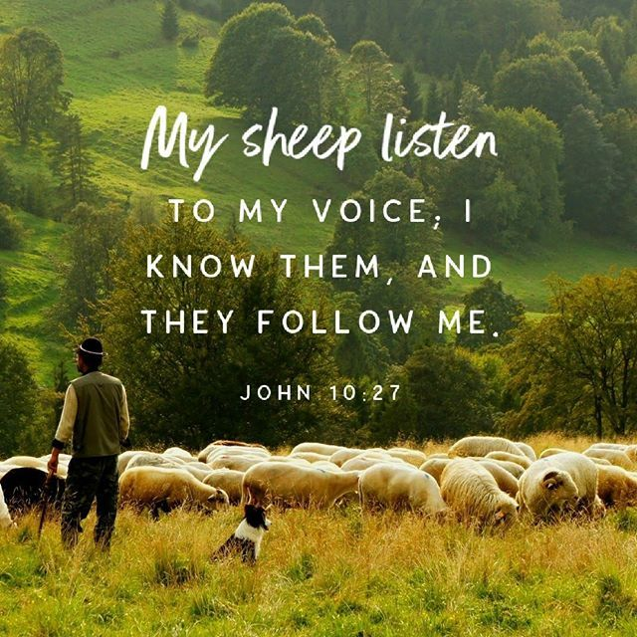

READ THIS SECTION BEFORE WORSHIP BEGINS:
Welcome to our worship together, at home.
Please have a Bible by your side for your use and, for those of you who are watching live on Facebook, we suggest that have the links to today’s two songs already open and set to play as our worship comes to an end -so that you can sing them without delay, as part of your worship.
………………..
WELCOME & INTRODUCTION:
Let us take this moment to stop whatever else we are doing and still our bodies and minds.
This is God’s time. Sit comfortably. Picture Jesus with you, sitting alongside you and be still with Him. Know He truly loves you and care for you.
Now picture our church family all joining you to worship God in this moment in their own homes. Know that we are worshipping together, even though we can’t see each other.
Remember that we are one in the Lord.
If you aren’t following the service on FB, we suggest that, if you are alone, you say the prayers and readings aloud. If you are with others, choose someone to lead and the rest of you join in with the words in bold. On FB, simply join in the words in bold.
………………..
Alleluia Christ is risen
He is risen indeed Alleluia

As a Church Family we come together either on Facebook or as we read this service to praise and worship God, Father, Son and Holy Spirit. We continue to celebrate Jesus’ resurrection from his death on the cross and to reflect on all that Jesus did for each one of us. We celebrate all that he does for us each day and all that he will do for us for into eternity. Today we listen or read as Jesus describes himself using the wonderful image of a shepherd: the good shepherd, the best shepherd. He is the shepherd who willing goes after the lost and carries them home safely.

The Call to Worship:
Remember Jesus Christ raised from the dead:
If we have died with him, we will also live with him:
If we endure with him, we will also reign with him:
if we deny him, he will also deny us;
if we are faithless, he remains faithful.

Now let’s be silent as we remember before God the ways in which we have let Him down over the past week, as we prepare to ask for His forgiveness.

Let us confess our sins in penitence and faith, firmly resolved to keep God’s commandments and to live in love and peace with all.

Most merciful God, Father of our Lord Jesus Christ, we confess that we have sinned in thought, word and deed. We have not loved you with our whole heart. We have not loved our neighbours as ourselves. In your mercy forgive what we have been, help us to amend what we are and direct what we shall be that we may do justly, love mercy and walk humbly with you, our God. Amen

Almighty God, you forgive all who truly repent.
Have mercy upon us, pardon and deliver us from all our sins;
Confirm and strengthen us in all goodness;
And keep us in life eternal;
Through Jesus Christ our Lord. Amen

On the FB Live Video, Catherine now reads a version of the Good Shepherd from ‘The Children’s Bible’

We say the ‘prayer for the Day’ together:

Almighty God, whose Son Jesus Christ is the resurrection and the life; raise us, who trust in him, from the death of sin to the life of righteousness that we may seek those things which are above, where he reigns with you in the unity of the Holy Spirit, one God, now and forever. Amen

Now read John 10: 1-10 or listen to Chris read it on FB.

Reflections on the Bible reading – the sermon!
- Jesus is the Good Shepherd – he knows us, loves us, cares for us, leads us, offers us salvation and ‘life to the full.’
- We are the ‘sheep’ – we have to listen to him, follow him, obey him, trust him and remain within the flock – the Church.
- Jesus shepherds us through ‘under shepherds’ – Church ministers. 1 Peter 5.1 ‘To the elders, I appeal, be shepherds of the flock .. be examples to the flock.’
- At our ordination as priests in the C of E, we ministers are told to set the ‘example of Good Shepherd before them.’ We are to care for the flock, serve them with joy and to build them up in faith. And these tasks are a deep privilege for those of us who are in ministry.
- What’s definitely trickier is the call to us to do all in our power to bring our flocks to loving obedience to Christ.’
- First we are to seek to encourage others to come to faith, but then our responsibility is to encourage those who already are in the Lord’s family to grow in holiness, faith and hope and love – to believe, belong and behave rightly.
- Our starting point, as the ordination service tells us, is always the Bible, the ‘Word of God’: we ministers have to proclaim it in worship, to teach it and to preach it; and, where necessary, to admonish and call people to repent – turn away from – their sins; pray for their congregations.
- And of course we ourselves have to go there first with our own lives: we must be examples of faithful, godly, true discipleship to our congregations.
- It’s a hard calling. A calling to love God and to love God’s people with a love like that of parents with their children: a love that is deep and selfless, a love that puts the growth of the children before its own comfort – or theirs – and a love that takes such joy in the child’s achievements.
- It’s almost always a challenging line to tread and we ministers need the help of the Holy Spirit to exercise their ministries. But we also need…
- Your prayers: Heb 13.7 ‘Pray for your leaders, who spoke word of God to you. Consider outcome of their life and imitate their faith.’
- And your trust, respect and obedience: Heb 13.17 ‘Obey your leaders, as they will have to give an account to God. Obey them, so that their work will be a joy.’ Church leaders need their flocks to trust them, respect them, realize that their ministers are always and only seeking their growth in holiness. Leaders need people to be open to being taught, and to being rebuked when needed.
- We need these things not for ourselves, but for the sake of the glory of the Kingdom in us all.
- Three decades ago, I was called into the ministry of the C of E. Now I am called to be your minister here in Lordshill. Today I commit myself once again to seeking to fulfil this work of priestly ministry among you and for you.
- You have been called to be the ‘sheep.’ Will you commit yourself once again to seeking to fulfil the work of the sheep, so that together we can be what the Lord wants us to be for his Church and our community?

Now let’s affirm our faith together:

Christ died for our sins in accordance with the Scripture; he was buried; he was raised to life on the third day in accordance with the Scripture; afterwards he appeared to his followers, and to the apostles; this we have received, and this we believe. This is the faith of the Church
This is our faith. We believe and trust in one God, Father, Son and Holy Spirit. Amen
Prayers Time: on FB, Catherine will now lead our prayers:
Lord God Almighty, we come to You with our prayers this Sunday, in the name of Jesus Christ and in the power of the Holy Spirit.
We pray for all our Church Family; may each know your closeness and peace. We especially lift to you those that are not well at this time, those that our finding the isolation very difficult. May each know your healing touch and that you are with them, wherever they may be.
Lord of life, In your mercy hear us
Lord we pray for all the countries and nations of the world fighting the Coronavirus. We thank you for all the understanding of the virus that has been gained and the places where the impact of the virus appears to be declining. Father we know you are mightier than any virus or any disaster. Please give wisdom to world leaders, politicians, and medical and scientific experts as they make decisions and give advice. Lord please may we individually and as nations be generous to help each other
Lord of life, In your mercy hear us
We lift to you all those that are continuing to work and come into close contact with others at this time. We remember the hospital staff, doctors, nurses, cleaners, porters and ambulance staff. We lift to you care assistants working so diligently in difficult times and factory workers, shop employees and drivers. Thank you for all people that are helping the country to continue to function and provide care as required.
Lord of life, In your mercy hear us
We remember with thanksgiving all those that have died … strengthen all who mourn, with the sure hope that, in Christ, their loved ones are raised to fullness of life.
Lord of life, In your mercy hear us
Good Shepherd we pray for all people during this difficult time when we are also celebrating your dying and raising from the dead, that all ears and hearts and minds may be opened to hear your call to them. That each one may know and accept your love and your care and protection. We pray for the coming of Your kingdom in and for the whole of your Creation.
Lord of life, In your mercy hear us
Father may your name be praised, honour, worshipped and held high throughout your world. Amen
Now let’s finish by saying together:
Blessed is the king who comes in the name of the Lord! Peace in heaven, and glory in the highest heaven! Let it be so! Amen.
Chris now leads us in our closing prayers together:

First, the Lord’s Prayer:
Our Father, who art in Heaven……

Next our church prayer whose words are taken from the Hillsong United worship song, ‘Oceans’:
Spirit lead us where our trust is without borders
Let us walk upon the waters
Wherever You would call us. Take us deeper than our feet could ever wander
And our faith will be made stronger
In the presence of our Saviour. Amen

And finally: Lord Jesus Christ, you humbled yourself in taking the form of a servant, and in obedience died on the cross for our salvation: give us the mind to follow you and to proclaim you as Lord and King, to the glory of God the Father. Amen.
Alleluia! Christ is risen.
He is risen indeed. Alleluia!

And the Blessing:
The God of peace, who brought again from the dead our Lord Jesus, that great shepherd of the sheep, make you perfect in every good work to do his will; and the blessing of God Almighty, Father, Son and Holy Spirit be with us and all those we love, this day and forever more Amen

We invite you to end your worship today either by using the lyrics overleaf to sing along on your own or by switching to the YouTube link on Lord’s Hill Church Facebook page to find today’s two worship songs and joining in with them.

WORSHIP SONG LYRICS

The Power of your Love

Lord I come to You
Let my heart be changed, renewed
Flowing from the grace
That I've found in You
Lord I've come to know
The weaknesses I see in me
Will be stripped away
By the power of Your love
Hold me close
Let Your love surround me
Bring me near
Draw me to Your side
And as I wait
I'll rise up like the eagle
And I will soar with You
Your Spirit leads me on
In the power of Your love

Lord unveil my eyes
Let me see You face to face
The knowledge of Your love
As You live in me
Lord renew my mind
As Your will unfolds in my life
In living every day
By the power of Your love

Hold me close
Let Your love surround me
Bring me near
Draw me to Your side
And as I wait
I'll rise up like the eagle
And I will soar with You
Your Spirit leads me on
In the power of Your love

Hold me…
(Songwriters: Geoff Bullock
The Power of Your Love lyrics © Warner Chappell Music, Inc, Universal Music Publishing Group, Music Services, Inc)

The Lord’s My Shepherd

The Lord’s my shepherd, I’ll not want;
He makes me lie in pastures green.
He leads me by the still, still waters,
His goodness restores my soul.

And I will trust in You alone,
And I will trust in You alone,
For Your endless mercy follows me,
Your goodness will lead me home.

He guides my ways in righteousness,
And He anoints my head with oil,
And my cup, it overflows with joy,
I feast on His pure delights.

And though I walk the darkest path,
I will not fear the evil one,
For You are with me, and Your rod and staff
Are the comfort I need to know.

(Stuart Townend Copyright © 1996 Thankyou Music)

Words of songs printed under CCLI no 16884
NIGHT PRAYER FOR THIS WEEK
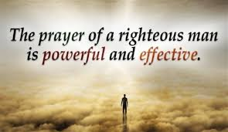

The Lord almighty grant us a quiet night and a perfect end. Amen
Our help is in the name of the Lord who made heaven and earth. Amen.
Alleluia. Christ is risen! He is risen indeed. Alleluia!

Spend a short time reflecting on your day and say sorry to God for anything you have done that you believe would make Him sad.

O God, make speed to save us.
O Lord, make haste to help us.
Glory to the Father and to the Son
and to the Holy Spirit;
as it was in the beginning is now
and shall be for ever. Amen. Alleluia.

Now from your Bible, read Psalm 23, then say:
Glory to the Father and to the Son
and to the Holy Spirit;
as it was in the beginning is now
and shall be for ever. Amen.

Say this prayer

For your Name’s sake, O God, lead us in the paths of righteousness and let your mercy follow us that we may dwell with for ever. Amen.

New Testament Reading – Hebrews 13.20-21
May the God of peace, who through the blood of the eternal covenant brought back from the dead our Lord Jesus, that great Shepherd of the sheep, equip you with everything good for doing his will, and may he work in us what is pleasing to him, through Jesus Christ, to whom be glory for ever and ever Amen

Now say your personal prayers: remembering perhaps five of your neighbouring households and five further afield.

Into your hands, O Lord, I commend my spirit.
For you have redeemed me, Lord God of truth.
Keep me as the apple of your eye.
Hide me under the shadow of your wings.
Let’s remember that Christ died for us,
so that, whether we wake or sleep,
we might live with him.

In peace we will lie down and sleep;
For you alone, Lord, make us dwell in safety.

Abide with us, Lord Jesus,
for the night is at hand and the day is now past.
As the night watch looks for the morning,
so do we look for you, O Christ.

Visit we beseech you Lord this house.
Drive far away from it all of the snares of the evil one.
May Your holy angels dwell here with us tonight
To keep us in Your peace.
And may Your blessing be upon us this night and forever more. Amen.
CHURCH NEWS

HOLY COMMUNION
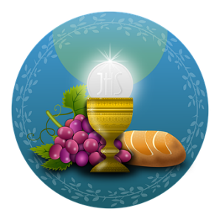
We will celebrate Holy Communion, as usual, on the second Sunday of May (10th) and then again on the last day of May (31st) which is the Feast of Pentecost. Those of you with good memories will recall that, last year, we marked Pentecost with a wonderful show outfits with a big or little hint of red in them. This year we invite you to do the same again and to send us photos of yourselves to share. We really are trying to find ways of still being together whilst apart!

GOD’S BIG PICTURE

If you remember, we started to follow this course in our Sunday sermons and home groups before the lock down began. As we didn’t get very far with it, and I know that memories are short, I’ve decided to start again with our worship on Sunday 7th June.
For those who have access to the internet, I will also provide links to the webpage, with video and summary and Bible study sheets. And for those who are not online, I will provide hard copies of the study sheets. They will come with this weekly letter.

We hope you enjoy getting back into learning about the Bible.

