SUNDAY WORSHIP SHEET:
28th FEBRUARY 2021 10.30am
2nd SUNDAY OF LENT: PSALM 139
KNOWN BY GOD, MADE BY HIM, ALWAYS IN HIS PRESENCE
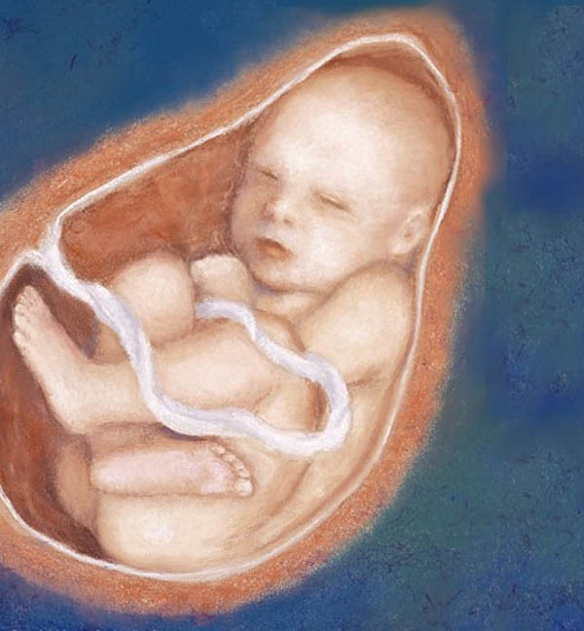

READ THIS SECTION BEFORE WORSHIP BEGINS:
Welcome to our time of worshipping together, but in different places – all at home (either with or without Facebook live streaming).
We suggest that you have a Bible by your side to use.
………………..
WELCOME & INTRODUCTION:
- Let us take this moment to stop whatever else we are doing and thinking about. This is God’s time. Sit comfortably. Picture Jesus with you, sitting alongside you and be still with Him. Know He truly loves and cares for you and He can be trusted.
- Now picture our church family all joining you to worship God in this moment in their own homes. Know that we are worshipping together, even though we can’t see each other.
- Remember that we are one in the Lord.
- If you aren’t following the service on FB, we suggest that, if you are alone, you say the prayers and readings aloud. If you are with others, choose someone to lead and the rest of you join in with the words in bold. On FB, simply join in the words in bold.
………………….
THE GREETING
Blessed is he who comes in the name of the Lord! We bless you from the house of the Lord!
THE INTRODUCTION -

Church Family, we come together today, to praise and worship God, Father, Son and Holy Spirit, still all in our own homes, but still united by God’s Holy Spirit.

Today we look at Psalm 139, one of the loveliest and most thought provoking, God-given Prayer Poems and learn how to use it in our own worshipping and prayer lives.

THE OPENING PRAYER (based on Psalm 48)

We wait in silence on your loving-kindness, O God, in the midst of your temple;
As your praise reaches to the ends of the earth, so gather in the nations to the beauty of your house;
through Jesus Christ our Lord. Amen.

We keep a time of silence, in the presence of the Lord.

THE CALL TO WORSHIP –from Psalm 100

Make a joyful noise to the Lord, all the earth
Bring your silence and your shouting, as introverts and extroverts.
Worship the Lord with gladness; come into his presence with singing.
Bring your songs and your stories, your struggles and your sacrifices.
Know that the LORD is God. It is he that made us, and we are his; we are his people and the sheep of his pasture.
He designed and created us, he understands us and is intensely interested in us.
Enter his gates with thanksgiving and his courts with praise. Give thanks to him and bless his name.
Bring your gifts and your personalities, your strengths and your weaknesses.
For the LORD is good; his constant love continues for ever, and his faithfulness to all generations.

We pray together.
Almighty God, by the prayer and discipline of Lent may we enter into the mystery of Christ’s sufferings, and by following in his Way come to share in his glory; through Jesus Christ our Lord. Amen
On Facebook, Catherine now reads a story to ‘set the scene.’
We sing, ‘Bless the Lord O my soul’
THE CONFESSION OF SINS (based on Psalm 139. 7-12)
Where can I go from your spirit?
Or where could I get away from your presence?
If I go up to the heavens you are there;
If I make my bed in the depths, you are there.
If I rise on the wings of the dawn
And settle on the far side of the sea,
Even there your hand will guide me
And your right hand will hold me fast.
If I asked the darkness to hide me
And the light become night around me,
Even the darkness will not be dark to you;
The night will shine like the day, for darkness is as light to you.

God, our Father: we come to you in sorrow for our sins, forgive what we have been, help us amend what we
are and shape what we shall be; that we may delight in your will, and walk in your ways; through Jesus Christ our Lord. Amen
PRAYER OF ABSOLUTION
May the God of love bring us back to himself, and forgive us our sins, and assure us of his eternal love in Jesus Christ our Lord. Amen
THE BIBLE READINGS – now read John 2.23-25 and Psalm 139 or listen to them read on Facebook.

THE SERMON – CHRIS. If you are not participating via Facebook, please now read the enclosed sheet which gives the words of the sermon for today. If you ARE participating via Facebook, please just watch and listen to Chris – and then after the service go to the sheet with the ‘script’ of the sermon included with the e-mailing.
THE AFFIRMATION OF FAITH
We believe in God the Father, from whom every family in heaven and on earth is named.
We believe in God the Son, who lives in our hearts through faith and fills us with his love.
We believe in God the holy Spirit, who strengthens us with power from on high.
We believe in one God Father, Son and Holy Spirit. Amen.
THE PRAYERS – On Facebook, Catherine will now lead our prayers which are based on Psalm 139 .
You have searched me, Lord and know me.² You know when I sit and when I rise; you perceive my thoughts from afar.
Lord we pray for the world: especially we pray for the countries racked with the covid 19 virus and suffering from a shortage of medical supplies. We ask that you would help to guide and direct those who are in government both here and overseas so that they may be as wise as serpents but gentle as doves in their decision making in this on-going situation.
Lord in your mercy, Hear our prayer.
⁷Where can I go from your Spirit? Where can I flee from your presence?⁸ If I go up to the heavens you are there; if I make my bed in the depths, you are there.
Lord, we pray for those who are struggling with any kind of sickness in body, mind or spirit. We, remember those who are recovering in hospital and at home. We also especially pray for those who mourn in these dark times. We think of those who are in financial difficulty and don’t know which way to turn. We ask Lord that you would bring comfort to all.
Lord in your mercy, Hear our prayer.
¹³For you created my inmost being; you knit me together in my mother’s womb.¹⁴I praise you because I am fearfully and wonderfully made.
Lord we thank you for the gift of life: for the breath that supports life, for the food of this earth that gives life and for the love of family and friends.
Lord in your mercy, Hear our prayer.
¹⁷ How precious to me are your thoughts concerning me, O God. How vast is the sum of them! ¹⁸Were I to count them , they would outnumber the grains of sand----when I awake I am still with you.
Lord we lift to you the Pray 168 initiative for our city and trust you for your timing for revival in it. We pray for our Archbishops Justin and Stephen; our Bishops Tim. David and Debbie and for Chris and Catherine and the all the members and friends’ of Lords Hill Church that you will help us all grow in love and knowledge of you.
Lord in your mercy, Hear our prayer.
²³ Search me, O God, and know my heart; test me and know my anxious thoughts. ²⁴ See if there is any offensive way in me, and lead me in the way everlasting.
Lord in your mercy, Hear our prayer.
Amen
We sing, ‘Waiting here for you.’
We pray together: THE LORD’S PRAYER

Our Father, who art in heaven,
Hallowed be thy name;
Thy kingdom come;
They will be done;
On earth as it is in heaven.
Give us this day our daily bread.
And forgive us our trespasses,
As we forgive those who trespass against us.
And lead us not into temptation;
But deliver us from evil.
For thine is the kingdom,
The power and the glory,
For ever and ever.
Amen

THE CHURCH PRAYER
To You God be the glory, great things You have done.
So loved You the world that You gave us Your Son,
Who Yielded His life an atonement for sin,
And opened the life gates that we all might go in.

We praise You Lord, we praise You, Lord,
We want the whole earth to hear Your voice.
We praise You Lord, we praise You, Lord,
We, Your people, rejoice.
We come to You, Father, through Jesus the Son,
we give You the glory,
For great things You have done. Amen

We sing
THE BLESSING AND DISMISSAL
May the word of Christ dwell in you richly, as you sing psalms and hymns and spiritual songs with thanksgiving in your hearts to God, and the blessing of God almighty, the Father, the Son and the Holy Spirit be among you and remain with you in within your home, this day, this week and for ever more. Amen
Let’s go in peace to love and serve the Lord. In the name of Christ. Amen!

WORSHIP SONGS FOR USE AT THE 10.30am SERVICE
Words of songs printed under CCLI no 16884
BLESS THE LORD O MY SOUL
Bless the Lord O my soul
O my soul
Worship his holy name
Sing like never before
O my soul
I'll worship your holy name
The sun comes up
It's a new day dawning
It's time to sing your song again
Whatever may pass and whatever lies before me
Let me be singing when the evening comes
Bless the Lord O my soul
O my soul
Worship his holy name
Sing like never before
O my soul
I'll worship your holy name
You're rich in love and you're slow to anger
Your name is great and your heart is kind
For all your goodness I will keep on singing
10, 000 reasons for my heart to find
Bless the Lord O my soul
O my soul
Worship his holy name
Sing like never before
O my soul I'll worship your holy name Sing like never before
O my soul I'll worship your holy name
And on that day when my strength is failing
The end draws near and my time has come
Still my soul will sing your praise unending
10, 000 years and then forever more
Bless the Lord O my soul
O my soul
Worship his holy name
Sing like never before
O my soul
I'll worship your holy name
O I'll worship your holy name
I will worship your holy name
Songwriters: Matthew James Redman / Jonas Carl Gustaf Myrin

PURIFY MY HEART
Purify my heart
Let me be as gold and precious silver
Purify my heart
Let me be as gold, pure gold
Refiner's fire,
My heart's one desire
Is to be holy
Set apart for You, Lord
I choose to be holy
Set apart for You, my Master
Ready to do Your will
Purify my heart
Cleanse me from within
And make me holy
Purify my heart
Cleanse me from my sin, deep within
Refiner's fire
My heart's one desire
Is to be holy
Set apart for You, Lord
I choose to be holy
Set apart for You, my Master
Ready to do Your will
Songwriters: Brian Doerksen

SHINE JESUS SHINE
Lord, the light of your love is shining
In the midst of the darkness, shining
Jesus, Light of the world, shine upon us
Set us free by the truth you now bring us
Shine on me, shine on me
Shine, Jesus, shine
Fill this land with the Father's glory
Blaze, Spirit, blaze
Set our hearts on fire
Flow, river, flow
Flood the nations with grace and mercy
Send forth your word
Lord, and let there be light
Lord, I come to your awesome presence
From the shadows into your radiance
By the blood I may enter your brightness
Search me, try me, consume all my darkness
Shine on me, shine on me
Shine, Jesus, shine …
As we gaze on your kingly brightness
So our faces display your likeness
Ever changing from glory to glory
Mirrored here may our lives tell your story
Shine on me, shine on me

Shine, Jesus, shine ….
Source: Musixmatch
Songwriters: Kendrick Graham A
Shine Jesus Shine lyrics © Make Way Music

