SUNDAY WORSHIP SHEET:
May 2nd 2021 10.30am
5th Sunday of Easter: Jesus the True Vine. A Communion Service
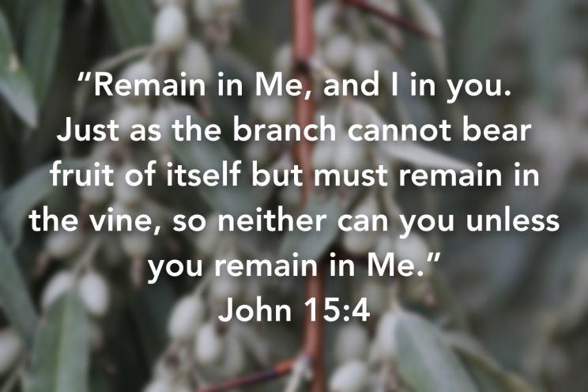

READ THIS SECTION BEFORE WORSHIP BEGINS:
Welcome to our time of worshipping together, but in different places – in Church or at home (either with or without Facebook live streaming).
We suggest that you have a Bible by your side to use.
………………..
WELCOME & INTRODUCTION:
- Let us take this moment to stop whatever else we are doing and thinking about. This is God’s time. Sit comfortably. Picture Jesus with you, sitting alongside you and be still with Him. Know He truly loves and cares for you and He can be trusted.
- Now picture our church family all joining you to worship God in this moment in their own homes. Know that we are worshipping together, even though we can’t see each other.
- Remember that we are one in the Lord.
- If you aren’t following the service on FB, we suggest that, if you are alone, you say the prayers and readings aloud. If you are with others, choose someone to lead and the rest of you join in with the words in bold. On FB, simply join in the words in bold.
………………….
THE GREETING
Alleluia! Christ is risen! He is risen indeed. Alleluia!

The Lord is here! His Spirit is with us!

THE INTRODUCTION -

Church Family, we come together today, to praise and worship God, Father, Son and Holy Spirit, still all in our own homes, but still united by God’s Holy Spirit.

Today we reflect on Jesus the True Vine and us as the branches, and our call to abide, remain in Him so as to be spiritually fruitful.

WE BEGIN TODAY WITH THE PEACE:

i am the vine and you are the branches.
Abide in us, that we may abide in you.
This is my commandment, that you love one another as I have loved you.
Abide in us, that we may abide in you.
Greater love has no one than this, that a man lay down his life for his friends.
Abide in us, that we may abide in you.
You are my friends if you do what I command you; love one another as I have loved you.
Abide in us, that we may abide in you.

Lord Jesus Christ, who said to your apostles, ‘Peace I leave with you, my peace I give to you;’ look not on our sins but on the faith of your Church and grant us the peace and unity of your kingdom, where you are live and reign, now and for ever. Amen.

The Peace of the Lord be always with you.
And also with you!

We greet each other with the Peace of the Lord.

On Facebook, we now sing, ‘A new commandment I give unto you.’

Catherine now reads a story to ‘set the scene.’

THE CONFESSION OF SINS
We thank you, gracious God, for Jesus Christ the true vine, with his roots eternally grounded in you. We rejoice that by grace we have been grafted into him, to be branches on a vine which bears the loveliest of all the fruits of earth. Yet we confess that all is not well with the way we live.
Time of silent reflection, calling to mind our sins
Please forgive us for the occasions when
we have been the ones to introduce disease into the vine, preferring its contamination to the vigour of health.
Forgive us for neglecting to draw deeply on the sap of Life, for our tendency to wander instead of growing on the framework your provide, for being content, and sometimes even proud of, a few sparse or undersized fruits, for the apathy which lets us to go through some seasons without bearing any fruit.
Have mercy on us. Please do not lose patience or sever us completely from the true vine. Rather heal our diseases; discipline and train our wandering tendrils; prune our unfruitful branches and cut away our diseased ones. May we remain in Christ and he in us, through all the changing seasons of life. Let us delight in bearing the fruits of love which are our true purpose and joy. For your Name’s sake. Amen!
PRAYER OF FORGIVENESS
Jesus said: “If you reside in me, and my words reside in you, ask whatever you will and it shall be done for you.” Friends, we have asked for forgiveness and correction. It has been truly done for us. It is being done for us. And it will be done for us. Thanks be to God! Amen

THE PRAYER OF THE DAY (together):
God of love,
plant us in the soil of your grace.
Nurture us with the strength of Christ,
the vine of everlasting life.
Enlighten us with the wisdom of your Spirit,
which flows through us today and all days.
Abide in us,
that we may abide in you
and live in your love.
In your holy name, we pray. Amen

THE BIBLE READINGS – now read or listen to Acts 8.26-40 & John 15.1-8
THE SERMON – CHRIS. If you are not participating via Facebook or are not in Church, please now read the enclosed sheet which gives the words of the sermon for today. If you ARE participating via Facebook or are in Church, please just watch and listen to Chris
THE AFFIRMATION OF FAITH
We believe in God the Father, from whom every family in heaven and on earth is named.
We believe in God the Son, who lives in our hearts through faith and fills us with his love.
We believe in God the Holy Spirit, who strengthens us with power from on high.
We believe in one God Father, Son and Holy Spirit. Amen
THE PRAYERS –Catherine now leads our prayers.
Dear Father in heaven, thank You that You are our heavenly Vinedresser and that You tend our lives with such care and concern. Cleanse us and prune us, and take away anything that you discover in us that does not glorify Your holy name.
Lord, in your mercy: Hear our prayer
Thank You, Father, that we are heavenly branches that are united to our heavenly Vine, the lovely Lord Jesus Christ. May His life flow through ours as sap flows through the branch that is engrafted into its parent stem. Fill us with His fullness so that we may live and move and grow and bear fruit as we abide more and more in Him.
Lord, in your mercy: Hear our prayer
Dear Lord, we know that we are commanded to abide in You and we desire to live our lives day by day, simply resting and abiding in You. Teach us Lord how to abide in You, so that all that is of ourselves will melt away as the Spirit of Christ pulses through our beings.
Give us the strength to be fruitful branches, for You alone are our sufficiency. Enable us to abide in Your love so that we may produce much fruit, out of the abundance of Your grace
Fill us, Father, with Your Spirit of the Vine, Christ Jesus our Lord. May we bring forth fruit, more fruit, much fruit to glorify Your Holy name.
Lord, in your mercy: Hear our prayer
Father , Jesus is the true vine and we are the branches. By your Spirit, produce the fruit of love, joy, peace, and patience in us for others to taste and enjoy. Keep us from hanging on to love for ourselves. Prune all selfishness from us and fill us with your love.
Lord, in your mercy Hear our prayer.

Have mercy on your earth and supply its needs. Where people are hungry, give food. Where people are in distress, comfort them. Where people are in trouble, bring order and peace. And turn the whole world to you in faith, repentance and praise.
Lord, in your mercy Hear our prayer.

Focus our love and our prayers now on people we know with special needs. Heal those who are unwell and others in need whom we now name silently in our hearts... (brief silence)
Lord, in your mercy... hear our prayer.

Thank you, Father, for hearing us and caring for us in all our needs. Constantly hear the prayers of your Son Jesus for us, and open our eyes that we may see you through him.

We ask all this in his holy name, for he lives and reigns with you and the Holy Spirit, one God, now and forever. Amen.

On Facebook, we sing, ‘This is my body, broken for you.’
THE EUCHARISTIC PRAYER - Chris
In Church and on Facebook, Chris will now lead the Eucharistic Prayer. If you are not participating via Facebook, please now read 1 Corinthians 11.23-26.

We pray together:

THE LORD’S PRAYER

Our Father, who art in heaven,
Hallowed be thy name;
Thy kingdom come;
They will be done;
On earth as it is in heaven.
Give us this day our daily bread.
And forgive us our trespasses,
As we forgive those who trespass against us.
And lead us not into temptation;
But deliver us from evil.
For thine is the kingdom,
The power and the glory,
For ever and ever.
Amen

COMMUNION -
On FB and in Church, Chris will break the bread and say the invitation to communion. He and Catherine will now receive the bread and the wine of Communion. Those in Church will be brought the bread of Communion.

If you are worshipping at home, you are invited to make a spiritual communion. You may find it helpful to use these words to guide your imagination as you do:

I see Jesus at the head of the table in the upper room.
I see the bread and the wine on the table before him.
I see Peter and James and John sat round the table.
I see Jesus take the bread in his hands.
I see Jesus bless the bread.
I see Jesus break the bread.
I see Jesus taking the cup of wine in his hands.
I see Jesus bless the wine.
I see Jesus bringing the bread to those who are there.
I see Jesus coming to me with the bread.
I hold out my hands.
I see Jesus put some bread into my cupped hands.
I hear Jesus say, ‘Take this and eat it; this is my body, given for you.’
I see Jesus bringing the wine to those who are in the upper room.
I see Jesus coming to me with the wine.
I see Jesus give me the cup.
I hear Jesus say, ‘Drink this; this is my blood of the new covenant poured out for you.’
I see Jesus return to the head of the table.
I hear Jesus say, ‘Do this to remember me.’
Jesus, I remember you! Thank you, Jesus!

PRAYERS AFTER COMMUNION
God of harvest,
gardener supreme,
you place us at the centre,
feed us, equip us and,
having provided for us,
look to a different harvest—
a fruitfulness of lives
in service to you
and others.
God of harvest,
feed us,
prune us
harvest us,
that our lives
might bring glory to you. Amen
THE CHURCH PRAYER
To You God be the glory, great things You have done.
So loved You the world that You gave us Your Son,
Who Yielded His life an atonement for sin,
And opened the life gates that we all might go in.

We praise You Lord, we praise You, Lord,
We want the whole earth to hear Your voice.
We praise You Lord, we praise You, Lord,
We, Your people, rejoice.
We come to You, Father, through Jesus the Son,
we give You the glory,
For great things You have done. Amen

On Facebook, we sing ‘’Lord of the Dance.’
THE BLESSING AND DISMISSAL
Go now, and love one another,
because love is from God.
Proclaim God’s salvation to every generation.
Remain in Jesus Christ,
and like branches of a vine, draw your life from him.
And may God the vine grower tend you and make you fruitful;
May Christ Jesus abide in you and give you life;
And may the Holy Spirit cast out all fear and fill you with God’s love.Amen.
We go in peace to love and serve the Lord, Alleluia. Alleluia!
In the name of Christ. Amen! Alleluia. Alleluia!
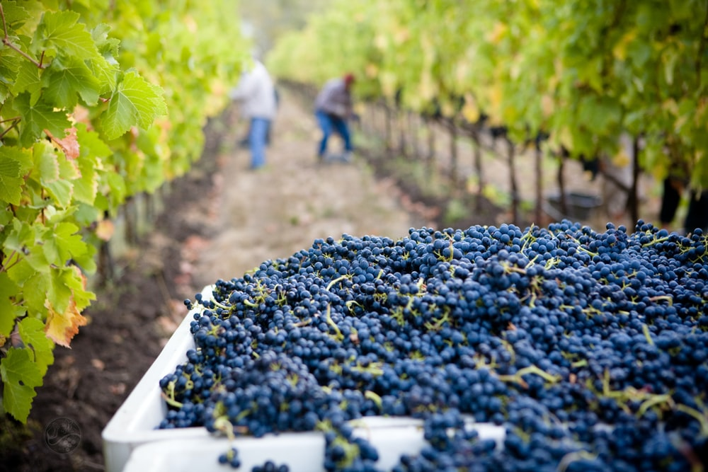

WORSHIP SONGS FOR USE AT THE 10.30am SERVICE
Words of songs printed under CCLI no 16884
A new commandment
A new commandment
I give unto you,
That you love one another
As I have loved you,
That you love one another
As I have loved you.
By this shall all men know
That you are My disciples,
If you have love one for another.
By this shall all men know
That you are My disciples,
If you have love one for another.
You are my friends if
You do what i command you.
Without my help you can nothing.
You are my friends if
You do what i command you.
Without my help you can nothing
I am the true Vine,
My Father is the gard’ner,
Abide in me, I will be in you.
I am the true Vine,
My Father is the gard’ner,
Abide in me, I will be in you.
Now, Love is patient,
Nor arrogant, nor boastful.
Love bears all things, love is eternal.
Now, Love is patient,
Nor arrogant, nor boastful.
Love bears all things, love is eternal
A new commandment I give unto you …
Source: Musixmatch
Songwriters: Thomas Tallis / David Skinner
A New Commandment lyrics © Novello & Co. Ltd.

This is my body
This is my body, broken for you,
bringing you wholeness, making you free.
Take it and eat it, and when you do, do it in love for me.

2. This is my blood poured out for you,
bringing forgiveness, making you free.
Take it and drink it, and when you do, do it in love for me.

3. Back to my Father soon I shall go.
Do not forget me; then you will see.
I am still with you, and you will know you’re very close to me.

4. Filled with my Spirit, how you will grow!

You are my branches; I am the tree.

If you are faithful, others will know

you are alive in me.

5. Love one another – I have loved you,

and I have shown you how to be free;

serve one another, and when you do,

do it in love for m

Lord of the Dance
I danced in the morning
When the world was begun,
And I danced in the moon
And the stars and the sun,
And I came down from heaven
And I danced on the earth,
At Bethlehem
I had my birth.
Dance, then, wherever you may be,
I am the Lord of the Dance, said he,
And I'll lead you all, wherever you may be,
And I'll lead you all in the Dance, said he
I danced for the scribe
And the pharisee,
But they would not dance
And they wouldn't follow me.
I danced for the fishermen,
For James and John
They came with me
And the Dance went on. Dance, then …
I danced on the Sabbath
And I cured the lame;
The holy people
Said it was a shame.
They whipped and they stripped
And they hung me on high,
And they left me there
On a Cross to die. Dance, then …
I danced on a Friday
When the sky turned black
It's hard to dance
With the devil on your back.
They buried my body
And they thought I'd gone,
But I am the Dance,
And I still go on. Dance, then …
They cut me down
And I leapt up high;
I am the life
That'll never, never die;
I'll live in you
If you'll live in me -
I am the Lord
Of the Dance, said he. Dance, then …
Source: LyricFind
Songwriters: Ronan Hardiman
Lord of the Dance lyrics © Universal Music Publishing Group

