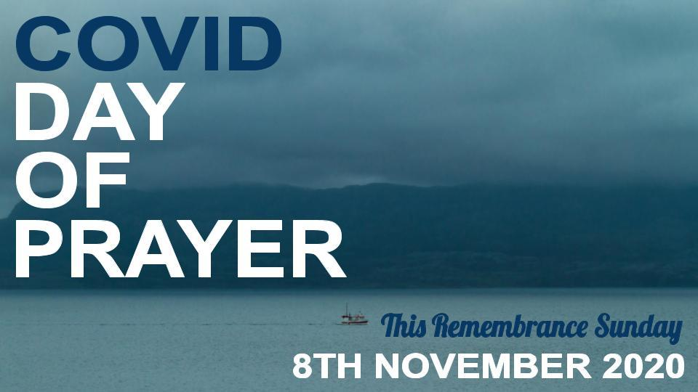

PRAYER RESOURCES

INTRODUCTION

The inspiration for this ‘COVID Day of Prayer’ came from us finding out about the story of the ‘Miracle of Dunkirk.’ We knew the basic story of the rescue of the British Army by a huge flotilla of ships that crossed the Channel to pick them up from the beaches of Northern France in 1940. But we had not known of the clearly miraculous things that happened that made that rescue possible, nor of the National Day of Prayer, called by the British King, that preceded the rescue.

It really seems to us - and to others - that the prayers offered on that National Day of Prayer significantly affected what happened at Dunkirk. If you haven’t already done so, take a look at this inspiring video: https://www.youtube.com/watch?v=ulgEkXcXtd8 .

On that National Day of Prayer in May 1940, many people in Britain humbled themselves, turned to the Lord and prayed for a great deliverance. And a great deliverance came!

And now today we are all facing the greatest crisis since the Second World War, as the Coronavirus continues to rage, and human efforts to halt it seem to have only a very limited effect. Many across the world have lost their lives to the Virus. Millions more have had their lives and livelihoods utterly changed - and not for the better.

Yet sadly, today, not many are looking to God as the only one who can save and deliver for eternity those who turn to Him. Instead, the vast majority in our land continue to neglect or reject God and to go their own way.

But we, the followers of Christ in this generation, can turn to him. So we have arranged this COVID Day of Prayer that has the City of Southampton at its heart, but that is also reaching out to other churches and individuals further afield who have felt God’s call to join us.

The theme text for this Day of Prayer is 2 Chronicles 7.13-14. The LORD is speaking to Solomon, following the Dedication of the Temple in Jerusalem:
When I send … a plague among my people, if my people, who are called by my name, will humble themselves and pray and seek my face and turn from their wicked ways, then I will hear from heaven and will forgive their sin and heal their land.

These verses show what can be achieved by the earnest prayers of the people of God. Note the process involved in the verses:
- The people humble themselves and pray and seek God’s face and turn from their wicked ways (that’s repentance!)
- Then God will hear, forgive and heal.

God may or may not have sent the Virus, but He has certainly allowed it to happen. So it is right for us to turn to Him about it in earnest prayer, as those who are already His people and, in obedience to His word, to then humble ourselves and pray. It is right that we should pray that many in our land would seek His face and turn - turn away from relying on themselves and turn to God in humble dependence on Him, pleading for mercy from Him and accepting Jesus as their Lord and Saviour. Then, and only then, can we pray that He would hear our prayer, forgive the sins of many, and bring healing to our land and to all who live in it and bring an end to the Virus.

So we are TODAY going to place ourselves in the gap between our great God and His broken people. There are several in the Bible who had the courage and insight to “stand in the gap” and to intercede for others.

In Genesis 18 Abraham interceded for Sodom.

In Acts 7, Stephen prayed for those stoning him.

In Romans 10, Paul prayed for Israel’s salvation.

And of course, our Lord Jesus Christ is the master of standing in the gap. From the cross, He prayed “Father, forgive them, for they do not know what they are doing” (Luke 23:34) and now He continues to intercede for us (Hebrews 7:25).
But we use the account of Moses standing in the gap as our inspiration:

Exodus 32:9–14:

“I have seen these people,” the Lord said to Moses, “and they are a stiff-necked people. Now leave me alone so that my anger may burn against them and that I may destroy them. Then I will make you into a great nation.”

But Moses sought the favour of the Lord his God. “Lord,” he said, “why should your anger burn against your people, whom you brought out of Egypt with great power and a mighty hand? Why should the Egyptians say, ‘It was with evil intent that he brought them out, to kill them in the mountains and to wipe them off the face of the earth’? Turn from your fierce anger; relent and do not bring disaster on your people. Remember your servants Abraham, Isaac and Israel, to whom you swore by your own self: ‘I will make your descendants as numerous as the stars in the sky and I will give your descendants all this land I promised them, and it will be their inheritance forever.’” Then the Lord relented and did not bring on his people the disaster he had threatened.

To stand in the gap is to intercede and plead for God’s mercy.

In God’s wisdom and sovereignty, he chooses to use the prayers of his people to accomplish his will.

He still seeks those who will stand in the gap for friends and family, for communities and cities, for people groups and nations.

Like Abraham and Moses, we should be willing to stand in the gap, asking God to spare and to save. Remember what it says in James 5.16: ‘The prayer of a righteous person is powerful and effective.’ As those who have been made righteous by Christ, we can be assured that our prayer is indeed ‘powerful and effective.’

Remember also that in Luke 18.1-8, Jesus tells the parable of the persistent widow, through which he encourages us that we ‘should always pray and not give up.’ So we have to be persistent in our prayer, always - but particularly on this day of prayer. But note the sting in the tail at the end of verse 8: ‘When the Son of Man comes, will he find faith on the earth?’ This once again implies we have to be praying for many to find faith in Him before He comes again, as well as for an end to the present pandemic.

And we can expect God to act on our prayers, if they are according to His will - but we must not assume that He will act in exactly the way we think He will or should. He knows what is best for us, and we must affirm Him as Lord of the whole of creation, even of the pandemic, who will act as He knows best.

************
These prayer resources are in four sections:
- Prayers of humbling and confession;
- Prayers for repentance and revival;
- Prayers for an end to the Virus, and for the healing of those who have been most affected by the pandemic.
- A conclusion

You are invited to use them in whatever way best suits you. At Lord’s Hill Church, Southampton, on 8th November 2020, we will be holding times of prayer in the Church building as well as the usual act of worship at 10.30am. At 8am, we will be using the prayers of humbling and confession, at 2.30pm the prayers for repentance and revival; and at 4.30pm the prayers for an end to the Virus and for those affected by the pandemic, and the conclusion. We will also be making these resources available to all our members, for them to use through that day, whether or not they are able to attend one or more of the meetings in our church building.

Thank you for sharing in this day. May God bless you - and use all our prayers for his glory and for the furthering of his Kingdom.

Chris and Catherine Knights
Lord’s Hill Church, Southampton
revchrisknights@gmail.com

The lyrics of worship songs are printed under CCL no 16884

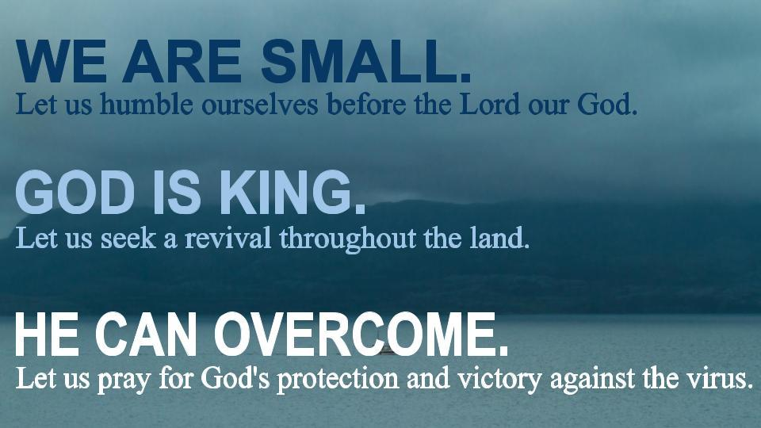

8AM - PRAYERS OF HUMBLING OURSELVES AND CONFESSING OUR OWN SINS

Please note: in shared worship, everyone speaks the words in bold. Otherwise only the worship leader speaks out loud.

‘When I send … a plague among my people, if my people, who are called by my name, will humble themselves and pray and seek my face and turn from their wicked ways, then I will hear from heaven and will forgive their sin and heal their land.’ (2 Chronicles 7.13-14 NIV)

Submit yourselves, then, to God. Resist the devil, and he will flee from you. Come near to God and he will come near to you. Wash your hands, you sinners, and purify your hearts, you double-minded. Grieve, mourn and wail. Change your laughter to mourning and your joy to gloom. Humble yourselves before the Lord, and he will lift you up. (James 4.7-10 NIV)

Prayer time:
Gracious and righteous God, we praise You that You are always active - moving throughout history, moving in our individual lives, striving to work out Your purposes. You are not remote or detached from our world, holding Yourself aloof from our human condition, unconcerned about our daily affairs, but You are intimately involved in every aspect of our experience.
Gracious and righteous God, we rejoice in your eternal purpose.
We praise you for your immeasurable love, always watching over us, constantly reaching out to bless, daily by our sides. You are a God full of mercy, always ready to forgive, always prepared to give us the benefit of the doubt, always eager to wipe the slate clean and start again.
Gracious and righteous God, we rejoice in your eternal purpose.
Forgive us that, because of Your intimate presence with us, sometimes we become over-familiar with You - losing sight of Your holiness, forgetting Your commandments, becoming careless in our discipleship. Forgive us that we can lose our sense of wonder - no longer open to all that You can do among us, no longer expecting the unexpected, no longer the people with the courage to dream dreams.
Gracious and righteous God, we rejoice in your eternal purpose.
You are all-good and all-righteous - stretching out Your hand in judgement, punishing wrong-doing, destroying evil. You are all-loving and all-powerful - reaching out Your hand to bless, to reward faithfulness, to vindicate truth.
Gracious and righteous God, we rejoice in your eternal purpose.
Save us from becoming complacent about judgement and grace - from imagining our thoughts or actions do not matter to You, from becoming apathetic or defeatist in our mentality, from losing heart when evil appears to triumph over good. Help us to recognize the destructive consequences of our sinfulness, to see our faults and to confess them honestly to You, to discover the joy that comes from being at one with You, and to look forward to that day when Your will shall be done and Your kingdom come.
Gracious and righteous God, we rejoice in the certainty of your final triumph, through Jesus Christ our Lord. Amen.
(From Nick Fawcett, Prayers for All Seasons, Kevin Mayhew, 1998, p. 464f.)
Say Psalm 51.1-17
1 Have mercy on me, O God,
according to your unfailing love;
according to your great compassion
blot out my transgressions.
2 Wash away all my iniquity
and cleanse me from my sin.
3 For I know my transgressions,
and my sin is always before me.
4 Against you, you only, have I sinned
and done what is evil in your sight;
so you are right in your verdict
and justified when you judge.
5 Surely I was sinful at birth,
sinful from the time my mother conceived me.
6 Yet you desired faithfulness even in the womb;
you taught me wisdom in that secret place.
7 Cleanse me with hyssop, and I will be clean;
wash me, and I will be whiter than snow.
8 Let me hear joy and gladness;
let the bones you have crushed rejoice.
9 Hide your face from my sins
and blot out all my iniquity.
10 Create in me a pure heart, O God,
and renew a steadfast spirit within me.
11 Do not cast me from your presence
or take your Holy Spirit from me.
12 Restore to me the joy of your salvation
and grant me a willing spirit, to sustain me.
13 Then I will teach transgressors your ways,
so that sinners will turn back to you.
14 Deliver me from the guilt of bloodshed, O God,
you who are God my Savior,
and my tongue will sing of your righteousness.
15 Open my lips, Lord,
and my mouth will declare your praise.
16 You do not delight in sacrifice, or I would bring it;
you do not take pleasure in burnt offerings.
17 My sacrifice, O God, is a broken spirit;
a broken and contrite heart
you, God, will not despise.

Reflect on these words. Notice how, in this Psalm, there are eight steps for real repentance:

- Define the sin (verses 1-3);
- Appeal to God’s mercy (verse 1);
- Avoid defensiveness and see God rightly (v. 4);
- Look to Jesus’ blood for forgiveness (verse 7);
- Ask God to break and heal you (verse 8);
- Be Comforted by the Spirit (verse 11);
- Rejoice and proclaim truth (verses 12-15)
- Resolve to obey (verse 17 (https://www.thegospelcoalition.org/article/steps-repentance-psalm-51/)

Let us now call to mind our sin and the infinite mercy of God.
Keep a time of silence to recall and repent of your own sins before God, then pray:
God the Father, have mercy upon us.
God the Son, have mercy upon us.
God the Holy Spirit, have mercy upon us.
Holy, blessed and glorious Trinity, have mercy upon us.

From all evil and mischief;
from pride, vanity, and hypocrisy;
from envy, hatred, and malice;
and from all evil intent,
good Lord, deliver us.
From sloth, worldliness and love of money;
from hardness of heart
and contempt for your word and your laws,
good Lord, deliver us.
From sins of body and mind;
from the deceits of the world, the flesh and the devil,
good Lord, deliver us.
In all times of sorrow;
in all times of joy;
in the hour of death,
and at the day of judgement,
good Lord, deliver us.
By the mystery of your holy incarnation;
by your birth, childhood and obedience;
by your baptism, fasting and temptation,
good Lord, deliver us.
By your ministry in word and work;
by your mighty acts of power;
and by your preaching of the kingdom,
good Lord, deliver us.
By your agony and trial;
by your cross and passion;
and by your precious death and burial,
good Lord, deliver us.
By your mighty resurrection;
by your glorious ascension;
and by your sending of the Holy Spirit,
good Lord, deliver us.
Give us true repentance;
forgive us our sins of negligence and ignorance
and our deliberate sins;
and grant us the grace of your Holy Spirit
to amend our lives according to your holy word.
Holy God holy and strong, holy and immortal, have mercy upon us.

We keep a few moments of silence to recall the great mercy of God in Jesus.
Make our hearts clean, O God;
and renew a right spirit within us.

Father eternal, giver of light and grace,
we have sinned against you and against our neighbour,
in what we have thought,
in what we have said and done,
through ignorance, through weakness,
through our own deliberate fault.
We have wounded your love,
and marred your image in us.
We are sorry and ashamed,
and repent of all our sins.
For the sake of your Son Jesus Christ,
who died for us,
forgive us all that is past;
and lead us out from darkness
to walk as children of light. Amen.
(From Common Worship: Services and Prayers for the Church of England: Times and Seasons, Archbishops’ Council, 2000)
Silence.

Merciful Lord, absolve your people from their offences, that through your bountiful goodness we may all be delivered from the chains of those sins which by our frailty we have committed; grant this, heavenly Father, for Jesus Christ’s sake, our blessed Lord and Saviour, who is alive and reigns with you, in the unity of the Holy Spirit, one God, now and forever. Amen.

Keep a time of silent prayer, then end with the LORD’S PRAYER.
10AM - SING PRAISES TO GOD

Words of all songs printed under CCLI no 16884

To God Be the Glory

To God be the glory
Great things He has done
So loved He the world that He gave us His Son
Who yielded His life an atonement for sin
And opened the life-gate that all may go in

CHORUS:
Praise the Lord, praise the Lord
Let the earth hear His voice
Praise the Lord, praise the Lord
Let the people rejoice
Come to the Father
Through Jesus the Son
Give Him the glory
Great things He has done
O perfect redemption, the purchase of blood
To every believer the promise of God
The vilest offender who truly believes
That moment from Jesus a pardon receives
Chorus

Great things He has taught us, great things He has done
And great our rejoicing through Jesus the Son
But purer, and higher, and greater will be
Our wonder, our worship, when Jesus we see.

Chorus

Source: Musixmatch
Songwriters: Fred Bock / Fanny Crosby / William Doane

Freely, Freely

God forgave my sin in Jesus' name.
I've been born again in Jesus' name
And in Jesus' name I come to you
To share his love as he told me to.

Chorus:
He said 'Freely, freely you have received
Freely, freely give.
Go in my name, and because you believe others will know that I live.

All power is given in Jesus' name
In earth and heaven in Jesus name
And in Jesus' name I come to you
To share his power as he told me to.
He said 'Freely, freely you have received;

Chorus

God gives us life in Jesus' name
He lives in us in Jesus' name
And in Jesus' name I come to you
To share his peace as he told me to.

Chorus
Source: Musixmatch Songwriters: Carol Owens
Freely, Freely lyrics © Bud-john Songs Inc.

Every Praise
Every praise is to our God.
Every word of worship with one accord
Every praise every praise is to our God.
Sing hallelujah to our God
Glory hallelujah is due our God
Every praise every praise is to our God.
(repeat)
God my Saviour
God my Healer
God my Deliverer
Yes He is, yes He is, yes He is, yes he is
(repeat)
Now we repeat the whole song.

Lyrics – Hezekiah Walker

10.30am - Holy Communion
Remembrance Sunday:

COVID Day of Prayer

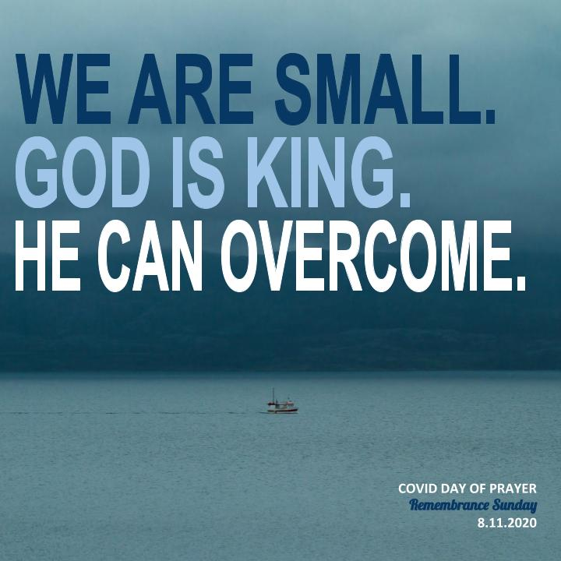

READ THIS SECTION BEFORE WORSHIP BEGINS:
Welcome to our time of worshipping together, but in different places - all at home once again (either with or without Facebook live streaming).
We suggest that you have a Bible by your side to use.
And, as usual, we suggest that those of you who are watching live on Facebook have the links to today’s songs already open and set to play so that you can sing them as a continuous part of our worship. If you don’t have Facebook, just read or sing the songs – words provided after the Order of Service – after you have used this Order.
………………..
WELCOME & INTRODUCTION:
At 10am, on Facebook, Chris & Catherine will lead us in singing three worship songs, as a preparation for worship – see overleaf for lyrics:
- Let us take this moment to stop whatever else we are doing and thinking about. This is God’s time. Sit comfortably. Picture Jesus with you, sitting alongside you and be still with Him. Know He truly loves and cares for you and He can be trusted.
- Now picture our church family all joining you to worship God in this moment in their own homes. Know that we are worshipping together, even though we can’t see each other.
- Remember that we are one in the Lord.
- If you aren’t following the service on FB, we suggest that, if you are alone, you say the prayers and readings aloud. If you are with others, choose someone to lead and the rest of you join in with the words in bold. On FB, simply join in the words in bold.
- Before the service please either watch this video: https://www.youtube.com/watch?v=ulgEkXcXtd8 or read the account of ‘The Miracle of Dunkirk’ from the sheet supplied.

Church Family, we come together either on Facebook or in church or reading this service alone at home, to praise and worship God, Father, Son and Holy Spirit.

Today, as we keep Remembrance Sunday, we remember not just those who have died as the result of war, but also the wonderful way in which God acted in 1940, following a National Day of Prayer, to secure the rescue of the British Army from Dunkirk. Remembering that has inspired us to hold a Day of Prayer today, to humble ourselves before God, to pray for many in our land to turn to God, and for God to bring a end to the COVID virus and to comfort, heal and sustain all those who have been adversely affected by the Virus.

THE GREETING
The Lord is here! His Spirit is with us!

THE CALL TO WORSHIP AND ACT OF PENITENCE:

Almighty God, we come this day to remember and learn – to remember the lessons of the past: the cost of war, the price of peace, the scope of human depravity, the extent of human self-sacrifice, and all Your wonderful acts.
Remind us of all we owe: Lest we forget.

Help us to learn those lessons – to live and work for peace, to fight only what is evil and corrupt, to serve and not to count the cost, to give our all in the cause of a better world, to humble ourselves before You and to pray earnestly and expectantly to You.
Remind us of all we owe: Lest we forget.

Almighty God, we come to remember all that you have done – your creative acts, your mighty deeds throughout history, your dealings with your people, your gift of Christ, your love experienced daily in our lives.
Remind us of all we owe: Lest we forget.

Forgive us that so often and so easily we do forget. We fail to remember your sovereign transforming power, to remember you in the good times as well as in the bad, to see you in the fellowship of your church, to count our many blessings, to recognize your hand in every moment of our lives.

Almighty God, through all things you remember us – help us to remember you!
Remind us of all we owe:
Lest we forget. We ask it in the name of Christ. Amen.

THE PRAYERS OF THE DAY
Eternal God, in whose perfect realm no sword is drawn but the sword of justice and no strength known but the strength of love: so guide and inspire the work of those who seek your Kingdom that all your people may find their security in that love which casts out fear and in the fellowship revealed to us in Jesus Christ our Saviour Amen.

Sovereign God, the defence of those who trust in you
and the strength of those who suffer:
look with mercy on the present afflictions of the world
and deliver us through our mighty Saviour Jesus Christ. Amen.

BIBLE READINGS

Now read 2 Chronicles 7.11-16 and Ephesians 6.10-20 or listen to them read on FB.

THE SERMON –
As usual, we have provided sermon notes for those who can’t access Facebook. For those who will be watching us, we invite you simply to listen to me (Chris) as I preach

THE SILENCE

PRAYERS: on FB, Catherine will now lead our prayers:
As we remember the ‘Miracle of Dunkirk’ today, we give you thanks for those who bravely sailed their ships across the English Channel to rescue the members of the British Army.
Lord, in your mercy Hear our prayer

But we remember more your wonderful hand in that rescue – those miraculous events that could only have been caused by you – Hitler’s order to halt the advance of his troops, the storm grounding the Luftwaffe, the extraordinary calm in the Channel, the way the British troops were repeatedly unharmed by enemy fire.
Lord, in your mercy Hear our prayer

We thank you that, because of what you did at Dunkirk, the whole course of the war was changed and, hard though the battle was, and many the casualties, whom we remember today with thanksgiving and love, victory against evil was assured.
Lord, in your mercy Hear our prayer

And we thank you that that Miracle of Dunkirk followed on from the National Day of Prayer in this country, when many humbled themselves before you, repented of their sins, sought your face and prayed for a great deliverance. We thank you for all who fought against evil by prayer at that time.
Lord, in your mercy Hear our prayer

And we ask you to sustain all those who today are battling against the Coronavirus – those who have contracted the disease and whose lives are threatened by it; doctors, nurses, carers, scientists and medical officers; those seeking to develop a vaccine; politicians making tough and unpopular decisions; ordinary citizens whose lives are now so limited by restrictions, poverty or loss of livelihood.
Lord, in your mercy Hear our prayer

And we remember before you all who have lost their lives to the Virus, and ask you to comfort those who mourn their deaths
Lord, in your mercy Hear our prayer

And we ask you to bring an end to this Pandemic. We have no power of ourselves to help ourselves. Only you can help us. We ask you today to do so!
Lord, in your mercy Hear our prayer

But we ask you, too, to work in the hearts of many in our land, to make them turn or turn to you as Lord and Saviour. Turn the people of this nation away from rejecting or neglecting you to humbling themselves before you and to seeking your face.
Lord, in your mercy Hear our prayer

Grant that we may indeed see revival and a real furthering of your Kingdom, your Rule, your Reign in this land and in every nation of the earth.
Merciful Father, Accept these prayers for the sake of your Son, our Saviour Jesus Christ. Amen.

The Peace- Chris
May the God of peace make you completely holy, ready for the coming of our Lord Jesus Christ.
The peace of the Lord be always with you.
And also with you

We greet those with we are with, with the Peace of Christ.

On Facebook, Chris will now lead the Eucharistic Prayer, with the usual responses. If you are not watching on Facebook, please now read 1 Corinthians 11.23-26

Let us continue our prayers by saying together the Lord’s Prayer:
Our Father, who art in Heaven……
On Facebook, Chris now breaks the bread.. As he and Catherine receive the Bread and the Wine, you are invited to make a ‘spiritual communion,’ by imagining Jesus giving you the bread and the wine and saying to you, ‘This is my Body,’ ‘This is my blood.’

Prayer after Communion
Let us commit ourselves to responsible living and faithful service.
Will you strive for all that makes for peace? We will.
Will you seek the heal the wounds of war? We will.
Will you work for a just future for all humanity? We will.

Merciful God, we offer to you the fears in us that have not yet been cast out by love: may we accept the hope you have placed in the hearts of all people, and live lives of courage, justice and mercy; through Jesus Christ our risen redeemer. Amen.

Next our church prayer whose words are taken from the Hillsong United worship song, ‘Oceans’:
Spirit lead us where our trust is without borders
Let us walk upon the waters
Wherever You would call us. Take us deeper than our feet could ever wander
And our faith will be made stronger
In the presence of our Saviour. Amen

And the Blessing:
God grant to the living, grace
To the departed, rest,
To the Church, the Queen, the Commonwealth and to all people, unity, peace and concord,
And to us to all God’s servants, life everlasting,
And the blessing of God, Father, Son and Holy Spirit, be among us now and for ever. Amen

Go in peace to love and serve the Lord
In the name of Christ. Amen

We invite you to end your worship today by either singing or reading aloud the worship song whose lyrics we’ve included after the words of this service.

WORSHIP SONGS

These are the words for and links to the songs that we invite you to join in online after the 1030am worship:

Oceans

You call me out upon the waters
The great unknown where feet may fail
And there I find You in the mystery
In oceans deep
My faith will stand
And I will call upon Your name
And keep my eyes above the waves
When oceans rise, my soul will rest in Your embrace
For I am Yours and You are mine
Your grace abounds in deepest waters
Your sovereign hand
Will be my guide
Where feet may fail and fear surrounds me
You've never failed and You won't start now
So I will call upon Your name
And keep my eyes above the waves
When oceans rise, my soul will rest in Your embrace
For I am Yours and You are mine
Spirit lead me where my trust is without borders
Let me walk upon the waters
Wherever You would call me
Take me deeper than my feet could ever wander
And my faith will be made stronger
In the presence of my Saviour
Spirit lead me where my trust is without borders
Let me walk upon the waters
Wherever You would call me
Take me deeper than my feet could ever wander
And my faith will be made stronger
In the presence of my Saviour
Spirit lead me where my trust is without borders
Let me walk upon the waters
Wherever You would call me
Take me deeper than my feet could ever wander
And my faith will be made stronger
In the presence of my Saviour
I will call upon Your name
Keep my eyes above the waves
My soul will rest in Your embrace
I am Yours and You are mine

Source: LyricFind
Songwriters: Joel Houston / Matt Crocker / Salomon Lighthelm

https://www.youtube.com/watch?v=dy9nwe9_xzw

Stand Up, Stand Up for Jesus

- Stand up, stand up for Jesus! ye soldiers of the cross;
Lift high His royal banner, it must not suffer loss:
From vict’ry unto vict’ry, His army shall He lead,
Till every foe is vanquished, and Christ is Lord indeed.
- Stand up, stand up for Jesus! The trumpet call obey:
Forth to the mighty conflict, in this His glorious day;
Ye that are men now serve Him against unnumbered foes;
Let courage rise with danger, and strength to strength oppose.
- Stand up, stand up for Jesus! Stand in His strength alone,
The arm of flesh will fail you, ye dare not trust your own;
Put on the gospel armour, and watching unto prayer,
Where calls the voice of duty, be never wanting there.
- Stand up, stand up for Jesus! the strife will not be long;
This day the noise of battle, the next the victor’s song;
To him that overcometh a crown of life shall be;
He with the King of glory shall reign eternally.

https://www.youtube.com/watch?v=79FT7kJpZ1g

2.30PM -
PRAYERS FOR REVIVAL AND TURNING TO GOD IN OUR LAND
Please note: in shared worship, everyone speaks the words in bold. Otherwise only the worship leader speaks out loud.

We begin with Scripture:

When I send … a plague among my people, if my people, who are called by my name, will humble themselves and pray and seek my face and turn from their wicked ways, then I will hear from heaven and will forgive their sin and heal their land. (2 Chronicles 7.13-14 NIV)

I urge, then, first of all, that petitions, prayers, intercession and thanksgiving be made for all people— for kings and all those in authority, that we may live peaceful and quiet lives in all godliness and holiness. This is good, and pleases God our Savior, who wants all people to be saved and to come to a knowledge of the truth. For there is one God and one mediator between God and mankind, the man Christ Jesus, who gave himself as a ransom for all people. (1 Timothy 2.1-6 NIV)

‘Seek the LORD while he may be found, call upon him while he is near. Let the wicked forsake his ways and the evil man his thoughts. Let him turn to the LORD, and he will have mercy on him, and to our God, for he will richly pardon.’ (Isaiah 55.6-7 NIV)

In the Book of Daniel, chapter 9, Daniel prays on behalf of his fellow-country-men:
In the first year of Darius son of Xerxes (a Mede by descent), who was made ruler over the Babylonian kingdom— in the first year of his reign, I, Daniel, understood from the Scriptures, according to the word of the Lord given to Jeremiah the prophet, that the desolation of Jerusalem would last seventy years. 3 So I turned to the Lord God and pleaded with him in prayer and petition, in fasting, and in sackcloth and ashes. I prayed to the Lord my God and confessed:
“Lord, the great and awesome God, who keeps his covenant of love with those who love him and keep his commandments, we have sinned and done wrong. We have been wicked and have rebelled; we have turned away from your commands and laws. 6 We have not listened to your servants, the prophets, who spoke in your name to our kings, our princes and our ancestors, and to all the people of the land.
“Lord, you are righteous, but this day we are covered with shame—the people of Judah and the inhabitants of Jerusalem and all Israel, both near and far, in all the countries where you have scattered us because of our unfaithfulness to you. We and our kings, our princes and our ancestors are covered with shame, Lord, because we have sinned against you. The Lord our God is merciful and forgiving, even though we have rebelled against him; we have not obeyed the Lord our God or kept the laws he gave us through his servants the prophets. All Israel has transgressed your law and turned away, refusing to obey you.
“Therefore the curses and sworn judgments written in the Law of Moses, the servant of God, have been poured out on us, because we have sinned against you. You have fulfilled the words spoken against us and against our rulers by bringing on us great disaster. Under the whole heaven nothing has ever been done like what has been done to Jerusalem. Just as it is written in the Law of Moses, all this disaster has come on us, yet we have not sought the favour of the Lord our God by turning from our sins and giving attention to your truth. The Lord did not hesitate to bring the disaster on us, for the Lord our God is righteous in everything he does; yet we have not obeyed him.
“Now, Lord our God, who brought your people out of Egypt with a mighty hand and who made for yourself a name that endures to this day, we have sinned, we have done wrong. Lord, in keeping with all your righteous acts, turn away your anger and your wrath from Jerusalem, your city, your holy hill. Our sins and the iniquities of our ancestors have made Jerusalem and your people an object of scorn to all those around us.
“Now, our God, hear the prayers and petitions of your servant. For your sake, Lord, look with favor on your desolate sanctuary. Give ear, our God, and hear; open your eyes and see the desolation of the city that bears your Name. We do not make requests of you because we are righteous, but because of your great mercy. Lord, listen! Lord, forgive! Lord, hear and act! For your sake, my God, do not delay, because your city and your people bear your Name.” (Daniel 9.1-17)
………………
So let’s pray now for those around us who are not yet members of the Body of Christ, not yet Christians, for those who have not yet repented of their sins and accepted Jesus as Lord. And we will invite you to spend more time in prayer straight after this broadcast.
Lord, we bring before You the people we know personally – the ones for whom we sense in our hearts you have especially called us to pray – who don’t yet know you as their Saviour and their Lord or who have somehow lost sight of you along the path of life.
In our mind’s eye, we picture them – members of our families, our friends, our work colleagues – our neighbours. And, as we picture them, we see ourselves bringing them to the foot of your cross – the cross that is the source of all life.
Lord, we ask that they will come to a knowledge of the truth that you are the one true God and that there is only one mediator between God and humanity, Christ Jesus.
Lord, we know that your deepest desire is to save them. Please give us the opportunity to share the Gospel with them. Give us the right words to say.
And, if it isn’t possible for them to hear from us about you, we ask you to send them someone else whose words they can hear.
And don’t delay Lord, because we don’t know the moment when you will return again or call us from this life on earth.
God, whose glory it is always to have mercy: be gracious to all who have gone astray from your ways, and bring them again with penitent hearts and steadfast faith to embrace and hold fast the unchangeable truth of your Word, even Jesus Christ our Lord.
Amen.
(From ECUSA, The Book of Common Prayer, 1979)

‘Build your Kingdom here’ - say (or sing!) the words of this great worship song by Rend Collective as a prayer for revival in our nation:

Come set Your rule and reign
In our hearts again
Increase in us we pray
Unveil why we're made
Come set our hearts ablaze with hope
Like wildfire in our very souls
Holy Spirit, come invade us now
We are Your Church
And we need Your power
In us
We seek Your kingdom first
We hunger and we thirst
Refuse to waste our lives
For You're our joy and prize
To see the captive hearts released
The hurt, the sick, the poor at peace
We lay down our lives for Heaven's cause
We are Your church
And we pray revive
This earth

Build Your kingdom here
Let the darkness fear
Show Your mighty hand
Heal our streets and land
Set Your church on fire
Win this nation back
Change the atmosphere
Build Your kingdom here
We pray

Unleash Your kingdom's power
Reaching the near and far
No force of hell can stop
Your beauty changing hearts
You made us for much more than this
Awake the kingdom seed in us
Fill us with the strength and love of Christ
We are Your church
Oh, and we are the hope
On earth

Build Your kingdom here
Let the darkness fear
Show Your mighty hand
Heal our streets and land
Set Your church on fire
Win this nation back
Change the atmosphere
Build Your kingdom here
We pray

SPEAK THIS VERSE TO END

Build Your kingdom here
Let the darkness fear
Show Your mighty hand
Heal our streets and land
Set Your church on fire
Win this nation back
Change the atmosphere
Build Your kingdom here
Oh, we pray (let's win this nation back)
Source: LyricFind
Songwriters: Chris Llewellyn / Gareth Gilkeson / Will Herron

Now let’s spend some time praying for Revival in our land.

Lord we ask for Your Holy Spirit to be poured out over our own communities, our City of Southampton, our nation and for any other places for whom our individual hearts cry out today.
Lord let the gates of each of these places be opened to You, our King of Glory.
Father come in and have complete dominion.

Lord hear us. Lord, graciously hear us.

Lord, release your Spirit of Divine Love, Forgiveness, Humility, Grace and Repentance over all these places. Pour your mercy over them in the name of Jesus Christ.
Help us all to deny and completely reject our love of the world and be restored to you.

Lord hear us. Lord, graciously hear us.

Lord we ask you to dismantle the powers of darkness in our city and nation and beyond – to paralyse all that is evil, in the name of Jesus Christ.
We pray that all those who have been misled by false beliefs will be divinely touched like you touched Saul who became Paul your beloved Apostle.

Lord hear us. Lord, graciously hear us.

Lord we ask for creative miracles and wonders in our city and nation and beyond to help many unbelievers come to Christ.
By faith we pray for many to be converted to faith in you, the one true God.

Lord hear us. Lord, graciously hear us.

Your word declares in Matthew 9:37-38 “The harvest truly is plentiful, but the laborers are few. Therefore, we pray to you, the Lord of the harvest, to send out laborers into your harvest here.

Lord hear us. Lord, graciously hear us.

Heavenly Father we ask for the righteous fear of the Lord to come into our city, our region and beyond and to abide with us from now on in Jesus name
We pray for your love to increase and fill all living things in this glorious land and beyond.
And Lord please protect the gatekeepers of this region. May they depend on your strength and wisdom in all their duties.

O God, who set before the great hope that the Kingdom shall come on earth, and taught us to pray for its coming: give us grace to discern the signs of it dawning, and to work for that perfect day when the whole earth shall reflect your glory; through Jesus Christ our Lord. Amen.

Keep a time of silent prayer.

Conclude by praying the LORD’S PRAYER

4.30PM - PRAYERS AGAINST THE VIRUS AND FOR THOSE AFFECTED BY THE PANDEMIC

Please note: in shared worship, everyone speaks the words in bold. Otherwise only the worship leader speaks out loud.

We begin with Scripture:
When I send … a plague among my people, if my people, who are called by my name, will humble themselves and pray and seek my face and turn from their wicked ways, then I will hear from heaven and will forgive their sin and heal their land. (2 Chronicles 7.13-14)

‘Seek the peace and prosperity of the city to which I have carried you .. and pray to the LORD for it, for if it prospers, you will prosper.’ (Jeremiah 29.7 NIV)

Say Psalm 91
1 Whoever dwells in the shelter of the Most High
will rest in the shadow of the Almighty.
2 I will say of the Lord, “He is my refuge and my fortress,
my God, in whom I trust.”
3 Surely he will save you
from the fowler’s snare
and from the deadly pestilence.
4 He will cover you with his feathers,
and under his wings you will find refuge;
his faithfulness will be your shield and rampart.
5 You will not fear the terror of night,
nor the arrow that flies by day,
6 nor the pestilence that stalks in the darkness,
nor the plague that destroys at midday.
7 A thousand may fall at your side,
ten thousand at your right hand,
but it will not come near you.
8 You will only observe with your eyes
and see the punishment of the wicked.
9 If you say, “The Lord is my refuge,”
and you make the Most High your dwelling,
10 no harm will overtake you,
no disaster will come near your tent.
11 For he will command his angels concerning you
to guard you in all your ways;
12 they will lift you up in their hands,
so that you will not strike your foot against a stone.
13 You will tread on the lion and the cobra;
you will trample the great lion and the serpent.
14 “Because he loves me,” says the Lord, “I will rescue him;
I will protect him, for he acknowledges my name.
15 He will call on me, and I will answer him;
I will be with him in trouble,
I will deliver him and honour him.
16 With long life I will satisfy him
and show him my salvation.”

Spend a few minutes reflecting on this Psalm
It is one of a very few that speaks of ‘pestilence’ and ‘plague’ and of being delivered from them by God. Note the progression in the Psalm:

- Verses 1-2: It is addressed to those who dwell in the shelter of God and make God (and not anything earthly) their refuge, fortress and place of trust.
- Verses 3-8: those who do are promised God’s protection.
- Verse 9 is a reminder about needing to turn to God. Verses 10-13: repeated assurances of God’s protection and salvation.
- Verses 14-16: these promises are for those who love God, acknowledge him and call upon him.

And so we pray for an end to the Virus:

‘ From lightning and tempest, from plague, pestilence and famine, from battle and murder and sudden death, Good Lord, deliver us’
(From the Litany in The Book of Common Prayer (1662)

O Almighty God, who in thy wrath didst send a plague upon thine own people in the wilderness, for their obstinate rebellion against Moses and Aaron, and also, in the time of time of King David, didst slay with the plague of pestilence three score and ten thousand, and yet remembering thy mercy didst save the rest; Have pity upon us miserable sinners, who are now visited with great sickness and mortality; that like as thou didst then accept of an atonement, and didst command the destroying Angel to cease from punishing, so it may now please thee to withdraw from us this plague and grievous sickness; through Jesus Christ our Lord. Amen.

(From The Book of Common Prayer (1662)
The old Book of Common Prayer is one of the few Prayer/Service books that has the courage to include specific prayers against plague.)

……………
Let’s now, using prayers adapted from ones created by Christian Aid ask God, to end the Pandemic.

Loving God,

Instil in our shaken souls
the belief and hope that all things
are possible with your creative love.

Instil in our shaken souls the belief and hope that you can end this Virus and that You will end this Virus.

Instil in our shaken souls a renewed belief that our world can be a more loving place – one in which strangers become friends, resources are generously shared.

Instil in our shaken souls the belief that you will either act to heal by your miraculous power or that science will source solutions.

Instil in our shaken souls the belief that the path will open to healing at the time that you know is right
in your perfect plan.

And until that moment, may we – your people – be strengthened and protected by your love that is always our comfort, strength and guide.

Amen Lord Have mercy.

And now, again using prayers created by Christian Aid, we pray for those battling against the Virus and for those most badly affected by it.

Even in the darkest moments, love gives hope.
Love compels us to fight against the Coronavirus, standing together in prayer with each other and with our neighbours near and far.
Love compels us to give and act as one as we see how tightly our futures are bound together.
So today, as we pray in our individual homes spread across our city and our nation, we unite as one family.

Together we lift up our hearts as we bring before you, God:
- The health workers tending the seriously ill
- The scientists working on a vaccination,
- The researchers analysing data and identifying trends,
- The media outlets working to communicate reality,
- And the supermarket workers, postal and delivery workers and all other key workers.

Together we thank you Lord for:
- The good news stories of recoveries and effective planning,
- The telephone calls and notes through letterboxes offering help and support to the lonely and isolated.
- The internet and telephones and technology that connects so many of us.
- And for those moments of awakening of appreciation of what is truly important.

And together we ask for your blessing on:
- Those who are unwell and concerned for loved ones.
- Those who were already very anxious before our Virus times.
- Those who are immune-suppressed or compromised.
- Those who are vulnerable because of underlying health conditions.
- Those who are in the ‘most at risk to Coronavirus’ categories.
- Those who are watching their entire income stream dry up or become much reduced.
- Those who have no choice but to go out to work.
- Those who are afraid to be at home.
- Those who are more lonely than they've ever been.
- Those who are bereaved and grieving.

God be the healer, comforter and protector of them all.

Be their strength, shield and provision.

Be their security, safety and close companion.

And raise up Your Church
to be Your well-washed hands and faithful feet
to be present to the pain
to respond with love in action
if even from a safe distance.

God, in Your mercy,
Hear our prayer.

And now from Romans 8: 38-39, let’s recall together the wonderful assurance:
‘For I am convinced that neither death, nor life, nor angels, nor rulers, nor things present, nor things to come… will be able to separate us from the love of God in Christ Jesus our Lord.’

God of heaven and earth,
in these times of isolation,
apart from loved ones
distant from friends
away from neighbours
thank you that there is nothing
in all of creation,
not even the Coronavirus,
that is able to separate us from your love.

And may your love that never fails
continue to be shared
through the kindness of strangers
looking out for each other,
for neighbours near and far
all recognising our shared vulnerability,
each of us grateful for every breath,
and willing everyone to know the gift
of a full and healthy life.
Keep us all in your care.

Amen.

Loving God,
strengthen our innermost being
with your love that bears all things,
even the weight of this global pandemic,
even the long haul of watching for symptoms,
of patiently waiting for this to pass,
watching and waiting,
keeping our gaze fixed on you,
and looking out for our neighbours
near and far.

Instil in our shaken souls
the belief and hope that all things
are possible with your creative love
for strangers to become friends
for science to source solutions
for resources to be generously shared
so everyone, everywhere, may have what they need
for your perfect love that knows no borders
may cast out any fear and selfishness that divides.

May your love that never ends
be our comfort, strength and guide
for the wellbeing of all and
the glory of God.

Amen.
…………….

Keep a time of silent prayer, then conclude with the LORD’S PRAYER.

7PM - CONCLUDING PRAYERS, followed by music and Scripture meditation

Please note: in shared worship, everyone speaks the words in bold. Otherwise only the worship leader speaks out loud.

Today the Coronavirus may still be all over the news, but even at its worst, we can all know peace by hoping and trusting in Jesus Christ who is strong and wise and good. We can hope and trust in Jesus for ourselves, for those we love and for the whole world as we bring everything to Him in prayers and supplications, with thanksgiving. (Phil 4:6).

So Lord, having humbled ourselves before you and prayed for many to truly turn to you, and having prayed for an end to the Pandemic and for those most badly affected by it, we come to you now with praise and thanksgiving in our hearts, as we say:

Psalm 138

¹ I will praise you, Lord, with all my heart;
before the “gods” I will sing your praise.
² I will bow down toward your holy temple
and will praise your name
for your unfailing love and your faithfulness,
for you have so exalted your solemn decree
that it surpasses your fame.
³ When I called, you answered me;
you greatly emboldened me.

⁴ May all the kings of the earth praise you, Lord,
when they hear what you have decreed.
⁵ May they sing of the ways of the Lord,
for the glory of the Lord is great.

⁶ Though the Lord is exalted, he looks kindly on the lowly;
though lofty, he sees them from afar.
⁷ Though I walk in the midst of trouble,
you preserve my life.
You stretch out your hand against the anger of my foes;
with your right hand you save me.
⁸ The Lord will vindicate me;
your love, Lord, endures forever—
do not abandon the works of your hands.
……………

And now, Lord, we come to you in our final prayer:

The Lord says: I, the Lord of sea and sky,
I have heard My people cry.
All who dwell in dark and sin,
My hand will save.
I who made the stars of night,
I will make their darkness bright.
Who will bear My light to them?
Whom shall I send?

Here we are Lord. Is it us, Lord?
We have heard You calling in the night.
We will go Lord, if You lead us.
We will hold Your people in our hearts.

The Lord says: I, the Lord of snow and rain,
I have borne my people's pain.
I have wept for love of them,
They turn away.
I will break their hearts of stone,
Give them hearts for love alone.
I will speak My word to them
Whom shall I send?

Here we are Lord. Is it us, Lord?
We have heard You calling in the night.
We will go Lord, if You lead us.
We will hold Your people in our hearts.

The Lord says: I, the Lord of wind and flame
I will tend the poor and lame.
I will set a feast for them,
My hand will save
Finest bread I will provide,
Till their hearts be satisfied.
I will give My life to them,
Whom shall I send?

Here we are Lord. Is it us, Lord?
We have heard You calling in the night.
We will go Lord, if You lead us.
We will hold Your people in our hearts. Amen.
(adapted from the song by Dan Schutte)
…………..

And so we go from prayer, sent by the Lord, to serving him in the world, fulfilling his purposes by our actions and by our words and by our lives as well as by our prayers.

